Vision / SCI Gateway R20.0 Issues
  - Version 1.1 7th September 2017
Vision users have reported some issues when using SCI Gateway from within the Vision system. This document gives some details on the issues and the current workarounds for them.

Session Terminated (when opening Referral)
There is a scenario where you can successfully log in to SCI Gateway from a patient consultation however when you try to create a new referral or open a parked referral the referral form opens with a Session Terminated error screen. This scenario is caused by a separate Internet Explorer window, i.e. not within a Vision window, being open somewhere, not necessarily showing anything to do with SCI Gateway. The current workaround is to close all IE windows.
The team at NSS recognise that this is an undesirable and unexpected behaviour and are urgently working on a fix. Timescales for the fix will be communicated as soon as possible.
For explanatory purposes, the steps to re-create this scenario are:
- Open a standalone Internet Explorer window, i.e. outwith Vision (it does not matter what page you display).
- Log in to SCI Gateway from a patient consultation.
- Create a new referral or open a parked referral so that the referral web form is displayed.
- Complete, park or cancel the referral.
- Click the Log off menu option in SCI Gateway.
- Close patient and open a new patient.
- Log in to SCI Gateway.
- Create a new referral or open a parked referral.
- The web form opens with a Session Terminated error.
Steps to clear the error from this point are:
- Close Internet Explorer (All windows).
- Create a new referral or open a parked referral.
- Referral form opens OK.
Note that you can also get the session terminated error when opening other pop-up windows, e.g. clicking the Filter icon in the work list status column or selecting the Set Status and Flags work list option. This is the same basic scenario as above and the workaround to close all IE windows works in these cases as well.

Session Terminated (Standalone gateway or in Vision)
Some users are occasionally reporting getting a session terminated screen, either within Vision or in SCI Gateway standalone.
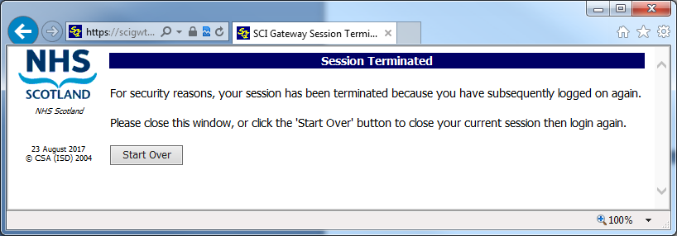
The session terminated screen indicates that the user has logged in to SCI Gateway elsewhere, e.g. logging in to SCI Gateway standalone
Example steps to generate a session terminated screen.
- Log in to SCI Gateway standalone as User A
- Log in to Vision
- Log in to SCI Gateway via Vision (as User A)
- Return to SCI Gateway standalone and try to display a new screen, e.g. referrals work list.
The Session Terminated screen will be displayed at step 4, because User A logged in via Vision on step 3 which terminates the standalone session from step 1.
. A necessary security enhancement in R20.0 prevents a user having multiple SCI Gateway sessions open at the same time. It is now not possible to be logged in to SCI Gateway in two different browser screens or even on two different machines. The solution is to log out of all SCI Gateway Sessions and log in to SCI Gateway again.
You cannot alternate between accessing SCI Gateway via standalone and Vision without logging in each time (NB: Vision logs you in to SCI Gateway for each patient as the mechanism for passing the patient details is via the log in. This has always been the case and is not new in R20.0). You cannot access SCI Gateway from 2 consultations at the same time as each consultation logs in to SCI Gateway separately.
The session terminated screen lets you know that you, or someone else, have subsequently logged in under your username elsewhere.
If you are sure that you have not logged in and have not shared the details of your SCI Gateway account then you should report the issue to your security officer or Help Desk as it indicates that your account may have been hacked.

Browser already in use
Since SCI Gateway R20.0 went live users have reported that they are getting a browser already in use screen when accessing the second or subsequent patient.
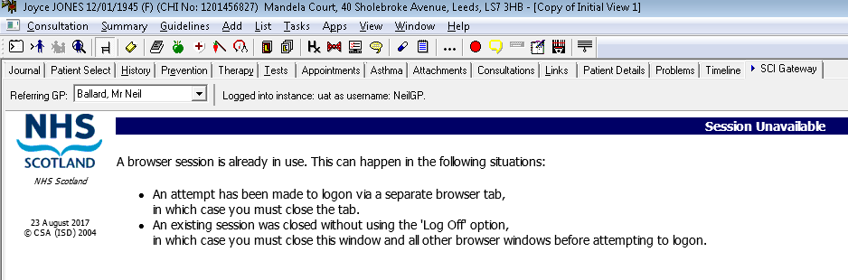
This error message is related to necessary security features introduced in SCI Gateway R20.0. Vision Users should click the Log Off menu item before closing the patient. You should then be able to open a new patient and go into SCI Gateway without receiving the “browser session is already in use” screen.
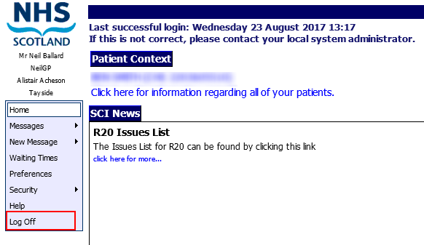
Click the Log Off menu option before closing a patient in Vision to avoid the Browser already in use screen.
Closing the patient and logging out of consultation manager and back in should reinstate access to SCI Gateway if you do get the browser already in use screen.
Note that in standalone Internet Explorer you can only open 1 SCI Gateway tab, subsequent tabs will display the browser already in use screen.
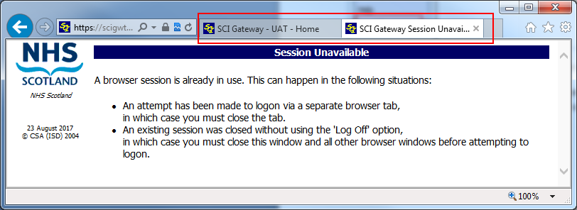
Two tabs open, cannot access SCI Gateway in the second tab, the first tab will continue to work.
NOTE: If you close the first tab, the working SCI Gateway one, leaving the second tab open, the second tab will not work and you will have to close ALL Internet Explorer windows to regain access to SCI Gateway.

Session token is empty
When creating a new message, opening a parked message or opening some other pop-up window, the pop-up window opens with a ‘Session token is empty screen’.
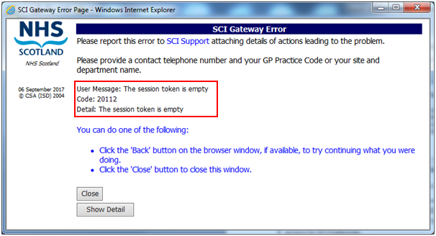
A known cause of this error is when, after clicking the Log Off menu option, you then manually enter your SCI Gateway username and password to log in again within the same patient.
For explanatory purposes, the known steps to recreate this are:
- Open a patient within a Vision consultation
- Open the Vision SCI Gateway screen (either through Summary or the SCI Gateway tab)
- Create a referral or do whatever you want in SCI Gateway.
- Click the SCI Gateway Log Off menu option
- At the SCI Gateway log on screen, enter your SCI Gateway username and password.
- Create a new referral, when clicking the Create button the referral window will open with the Session token is empty error screen.
To avoid the error do not manually log on after clicking the Log Off menu option. Instead close the patient consultation and then Vision will automatically log you in the next time you access SCI Gateway.
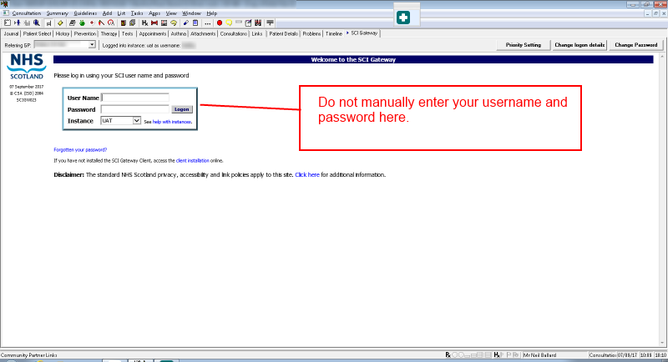
NSS are working on a fix for this issue. Timescales for the fix will be communicated as soon as possible.
NSS are currently investigating an issue where the user is getting a session token is empty error when trying to park or preview a referral. This error seems to be occurring for a small number of users who are using Terminal Services and looks to be related to Windows profiles and permissions.
If you are getting the Session token is empty screen within Vision itself and not in a pop-up window or can reliably re-create the issue without clicking the Log Off menu option then please report to the NSS Service Desk, email nss.NISGServiceDesk@nhs.net or telephone 0141 282 2100.

Summary of advice
To prevent or manage these error messages in Vision -
- To avoid the Session Terminated error when opening the referral form:
Do not have separate IE windows open when creating and sending referrals or other message types.).
This is temporary advice until NSS can release a fix.
- In order to avoid getting a Browser already in use screen:
Click the SCI Gateway Log Off menu option before closing a patient and moving on to the next patient.
This issue can only be addressed by major changes to the way that Vision and SCI Gateway interact and so this advice will stand.
- To avoid the “Session token is empty” error message when creating or opening a SCI Gateway message:
Having clicked the Log Off menu option, do not manually enter your SCI Gateway username and password to re-log on.
This is temporary advice until NSS can release a fix.

